Spearman rank correlation: AUDUSD and USDCAD
Method 02 / daily log returns / Alpari D1 full available history

Study setup
Logical pair: AUDUSD , USDCAD
Broker symbols: AUDUSD_i , USDCAD_i
Snapshot: 2026-11-03_majors_alpari_D1
Timeframe: D1
Matched return window: 1999-01-05 to 2026-11-02 (UTC bar dates)
Matched return count n: 7204
Dropped unfinished last bar dated 2026-11-03 UTC after a tick-volume check against the prior complete day.
Complete matched rows (CSV): AUDUSD-USDCAD_Spearman_D1.csv
Complete matched rows (HTML table): AUDUSD-USDCAD_Spearman_D1_data.html

Method carried forward
Spearman rho is Pearson correlation on the ranks of matched daily log returns of close, ln(close_t / close_t-1), in the broker quote direction. Ties use average ranks. Quotes are not inverted. rho is symmetric under swap of the two symbols. rho = 0 means no consistent rank-order link in this sample; it does not mean no link of any kind. The score is not a cause, not a lead, and not a trading signal. Daily rows are not independent draws, so the two-sided p-value and approximate Fisher interval are reported and treated as secondary to rho. Same-sample Pearson r is shown only as a side check; a large rho minus r gap can flag outliers or a non-straight link.

Results
Spearman rho: -0.596232
Two-sided p-value: 0
Approximate 95% Fisher interval: [-0.610913, -0.581141]
Same-sample Pearson r: -0.647362
rho minus r: 0.051130

Conclusion
Over 7204 matched daily log-return rows for AUDUSD and USDCAD (broker quote directions unchanged), Spearman rho is -0.5962 (negative, moderate rank-order association in this sample). Approximate 95% Fisher interval: [-0.6109, -0.5811]. Same-sample Pearson r is -0.6474 (rho minus r = 0.0511). Two-sided p under the usual independent-ranks model is 0; that model does not match linked daily FX returns, so treat p as secondary. This does not establish cause, lead-lag, or a lasting trading rule.

Charts
Daily closes

Daily log returns
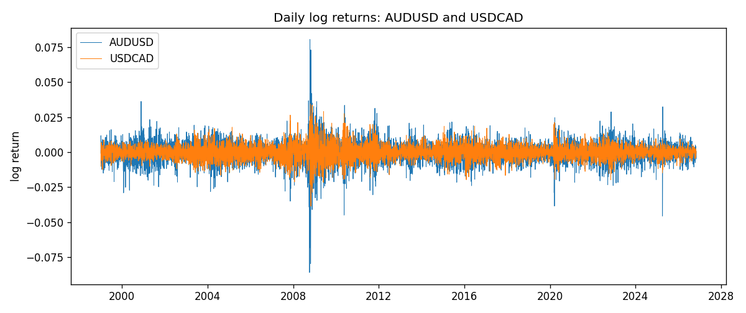
Log-return scatter
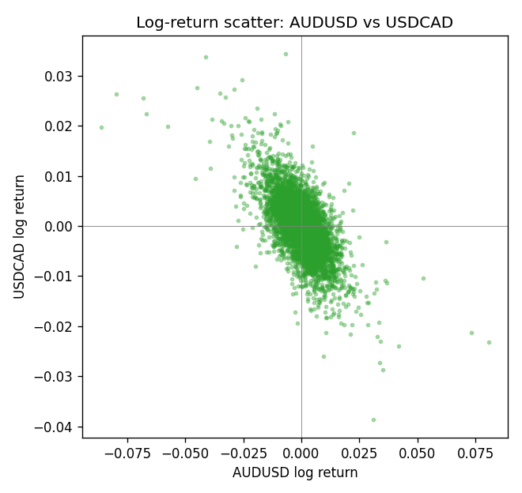
Rank-rank scatter
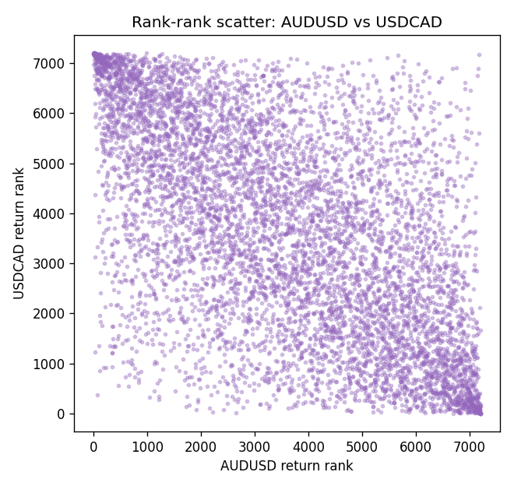

Data report
Every matched row that entered Spearman rho is stored in the sibling CSV named AUDUSD-USDCAD_Spearman_D1.csv. That file is the complete data archive for redrawing charts. Embedding all rows as a Word table is impractical at this length; the Word file holds the column list, column summaries, and the first and last 15 matched rows.
Columns: time, AUDUSD_open, USDCAD_open, AUDUSD_high, USDCAD_high, AUDUSD_low, USDCAD_low, AUDUSD_close, USDCAD_close, AUDUSD_tick_volume, USDCAD_tick_volume, AUDUSD_spread, USDCAD_spread, AUDUSD_real_volume, USDCAD_real_volume, AUDUSD_log_return, USDCAD_log_return
Column summaries (matched calculation rows)
column | count | mean | std | min | 25% | 50% | 75% | max
AUDUSD_open | 7204 | 0.75193151 | 0.13526075 | 0.4785 | 0.6610425 | 0.731405 | 0.8086175 | 1.10284
USDCAD_open | 7204 | 1.2670146 | 0.16899756 | 0.9168 | 1.118975 | 1.298545 | 1.372225 | 1.6183
AUDUSD_high | 7204 | 0.7559812 | 0.13582551 | 0.4878 | 0.6647 | 0.734785 | 0.81467 | 1.10795
USDCAD_high | 7204 | 1.2719163 | 0.16895637 | 0.9336 | 1.123375 | 1.30394 | 1.3767575 | 1.619
AUDUSD_low | 7204 | 0.74787477 | 0.13457623 | 0.4775 | 0.6577 | 0.727495 | 0.8042 | 1.0975
USDCAD_low | 7204 | 1.2624553 | 0.16903522 | 0.9056 | 1.11435 | 1.293585 | 1.3678925 | 1.6102
AUDUSD_close | 7204 | 0.75197934 | 0.13524694 | 0.4786 | 0.6611975 | 0.731695 | 0.808875 | 1.10169
USDCAD_close | 7204 | 1.2670334 | 0.16897258 | 0.916 | 1.11848 | 1.298615 | 1.372515 | 1.6137
AUDUSD_tick_volume | 7204 | 77316.143 | 138115.43 | 109 | 5421.75 | 43310.5 | 71296.75 | 1234623
USDCAD_tick_volume | 7204 | 80846.476 | 147183.52 | 56 | 5511.25 | 40857 | 71531.75 | 1410818
AUDUSD_spread | 7204 | 30.823709 | 16.885829 | 0 | 13 | 30 | 50 | 50
USDCAD_spread | 7204 | 23.505275 | 18.28107 | 0 | 9 | 17 | 40 | 60
AUDUSD_real_volume | 7204 | 5.2399076e+09 | 1.2535442e+11 | 0 | 0 | 0 | 0 | 3.811512e+12
USDCAD_real_volume | 7204 | 1.8332738e+10 | 9.6584767e+10 | 0 | 0 | 0 | 0 | 2.5751613e+12
AUDUSD_log_return | 7204 | 2.007e-05 | 0.0075444 | -0.08602525 | -0.00386183 | 0.00027895 | 0.00414528 | 0.0806166
USDCAD_log_return | 7204 | -1.21e-05 | 0.00514438 | -0.03859748 | -0.00283637 | 4.97e-05 | 0.00272781 | 0.03436319
First 15 matched rows (selected columns)
time | AUDUSD_close | USDCAD_close | AUDUSD_log_return | USDCAD_log_return | AUDUSD_tick_volume | USDCAD_tick_volume
1999-01-05 | 0.6215 | 1.5123 | -0.00080418179 | -0.010131666 | 1103 | 1345
1999-01-06 | 0.6289 | 1.5118 | 0.011836351 | -0.0003306769 | 1412 | 1803
1999-01-07 | 0.6345 | 1.5141 | 0.0088650256 | 0.0015202092 | 1468 | 1568
1999-01-08 | 0.6347 | 1.511 | 0.00031515916 | -0.0020495197 | 1225 | 914
1999-01-11 | 0.6393 | 1.5057 | 0.0072213815 | -0.0035137769 | 1318 | 953
1999-01-12 | 0.6362 | 1.5157 | -0.0048608485 | 0.0066194721 | 1908 | 1507
1999-01-13 | 0.6312 | 1.5226 | -0.0078902098 | 0.0045420214 | 1829 | 2141
1999-01-14 | 0.6295 | 1.5332 | -0.002696916 | 0.0069376546 | 1593 | 1816
1999-01-15 | 0.634 | 1.5245 | 0.007123101 | -0.0056905671 | 1604 | 1897
1999-01-18 | 0.6346 | 1.526 | 0.00094592471 | 0.00098344542 | 1430 | 1091
1999-01-19 | 0.6392 | 1.5302 | 0.0072225153 | 0.002748513 | 1733 | 1634
1999-01-20 | 0.64 | 1.5211 | 0.0012507819 | -0.0059646885 | 1901 | 1499
1999-01-21 | 0.6405 | 1.5146 | 0.00078094498 | -0.0042823796 | 1946 | 2007
1999-01-22 | 0.6327 | 1.5184 | -0.012252745 | 0.0025057712 | 1875 | 1713
1999-01-25 | 0.6302 | 1.5197 | -0.0039591468 | 0.00085579808 | 1413 | 1471
Last 15 matched rows (selected columns)
time | AUDUSD_close | USDCAD_close | AUDUSD_log_return | USDCAD_log_return | AUDUSD_tick_volume | USDCAD_tick_volume
2026-10-13 | 0.69821 | 1.4214 | 0.0035007712 | -0.0046395653 | 34335 | 50947
2026-10-14 | 0.69715 | 1.42356 | -0.0015193215 | 0.0015184751 | 43650 | 56126
2026-10-15 | 0.69191 | 1.41843 | -0.0075447063 | -0.0036101503 | 50656 | 63096
2026-10-16 | 0.69426 | 1.41357 | 0.0033906408 | -0.0034322068 | 40991 | 54908
2026-10-19 | 0.6978 | 1.41091 | 0.0050859986 | -0.0018835331 | 37273 | 52155
2026-10-20 | 0.70022 | 1.40569 | 0.0034620426 | -0.0037066008 | 38736 | 54450
2026-10-21 | 0.70275 | 1.4045 | 0.0036066384 | -0.00084691787 | 36307 | 51369
2026-10-22 | 0.70186 | 1.40081 | -0.0012672558 | -0.0026307268 | 43496 | 58806
2026-10-23 | 0.70353 | 1.40085 | 0.0023765656 | 2.85545e-05 | 39675 | 50387
2026-10-26 | 0.70128 | 1.40093 | -0.0032032829 | 5.7106554e-05 | 35142 | 49601
2026-10-27 | 0.70245 | 1.40449 | 0.0016669876 | 0.0025379458 | 34625 | 49541
2026-10-28 | 0.70533 | 1.39911 | 0.0040915541 | -0.0038379274 | 46279 | 56077
2026-10-29 | 0.70245 | 1.39895 | -0.0040915541 | -0.00011436495 | 45705 | 59551
2026-10-30 | 0.70316 | 1.39751 | 0.0010102376 | -0.0010298736 | 42925 | 59373
2026-11-02 | 0.69971 | 1.39837 | -0.0049184984 | 0.00061519094 | 41137 | 53578

